Sean Rettig
2015-05-28
ROB 421
Group 1
Individual Lab Report 3

So far, I have contributed primarily to the computer vision, remote control, and computer-microcontroller communication aspects of our robot, whilst also maintaining the project website and providing general support to the rest of the team as we designed, built, and tested our robot.

Since the last lab report, I assisted in redesigning the robot's frame to use extruded aluminum parts instead of wood and remachining/reconfiguring various parts to be more precise so the robot is physically more robust. I also provided a cart on which to mount the robot so that it can be transported easily and stationed next to the play table for the competitions.

I also improved the shot selection GUI significantly and performed testing with the remote controlling by using Teamviewer over a LAN connection. The robot is feature-complete aside from the swatting arm; all parts of the robot can be and are controlled by the computer, including the carriage, the launch motor, and the reload motor. The webcam is mounted just below the barrel of the launcher, and the remote user can select a cup to shoot for by drawing a box around it with their mouse on a webcam feed window, and the robot will use feature tracking to center itself on that cup by moving the carriage left or right until the cup is in the middle of the webcam view. To control the distance of the shot, the user selects whether the cup is in the first, second, or third row, and also whether a bounce shot is intended; the launch motor speed is adjusted automatically to optimal values determined by testing. In the event that manual tweaking is required (such as in the event of a headwind), the user also has manual control of the launch motor speed slider and the carriage. Once the speed is set and the carriage is in position, the user can press the space key to send a “shoot” command to the microcontroller, which then loads the next ball and shoots.

Our main challenges recently have been physical and electrical, mainly regarding the accuracy of our robot, which is still not anywhere near what we'd like to have. There were also a lot of minor issues involved with migrating to the new robot frame, though at this point, we've ironed most of those out and the new frame is proving to be much more reliable and easy to tweak. We also had some minor electrical issues, including with the voltage regulator overheating and one of our motor controllers being fried when our motors got stuck and stalled.

These three main areas of computer vision, remote control, and computer-microcontroller communication make up the core of the computer's responsibilities and are ultimately responsible for how the robot functions on a high level; computer vision failure will lead to slow and/or inaccurate shots and missed swatting opportunities, remote control failure may prevent us from even trying to shoot at all, and computer-microcontroller communication failure can lead to the robot being inaccurate, locking up, or even destroying itself.

My plans for the next week include helping my group members improve the shot accuracy of our robot, as this is still the primary issue.

Photograph of robot shooting, mounted on carriage and controlled by computer:

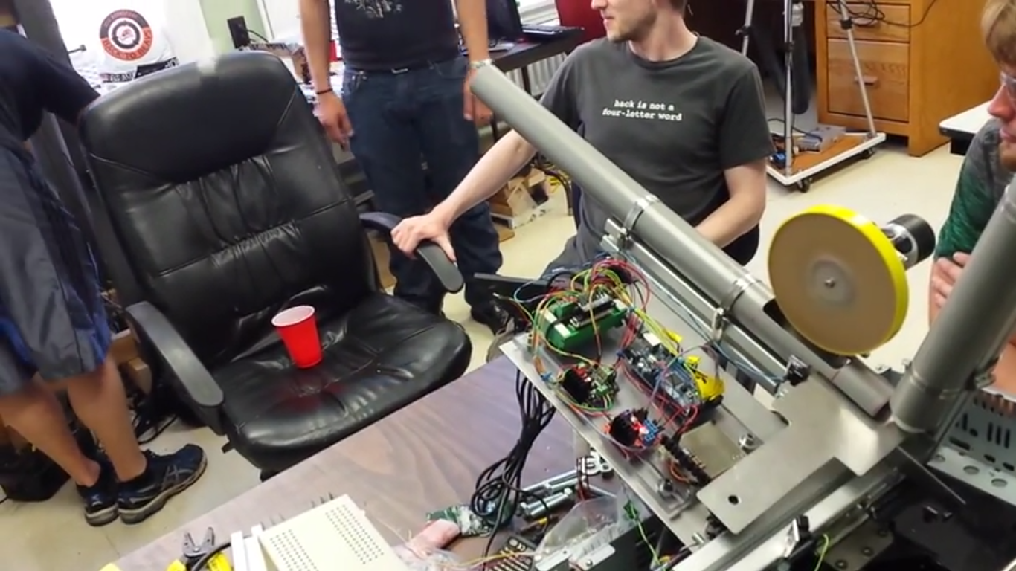
(video at https://www.youtube.com/watch?v=35qKwHBKnK8)

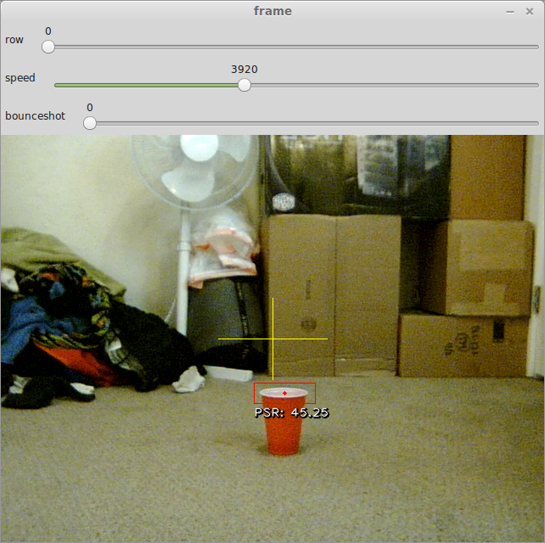
Screenshot of shot selection GUI:

